**Scientific report – Stage I (2018)**

**Theoretical investigation of gold nanoclusters with and without graphenic support in the reaction with molecules from the cross-coupling Suzuki-Miyaura reaction. Nanoparticle synthesis and catalytic testing for SM reaction. Theoretical testing of porphyrinic FeN4 structures for ORR**

**Suzuki-Myaura C-C cross coupling reaction on gold nanoparticles/nanoclusters**

**1. Experimental section**

**1.1 Catalyst preparation**

- few-layered graphene-supported (1.1.1) Au nanoplatelets (20-40 nm wide, 3-4 nm height) (collaboration with group of Prof. H. Garcia from Universidad Politécnica de Valencia) reported in detail in our previous work [1].

- the preferential morphology of Au nanocrystals is nanoplatelets (revealed by TEM and Raman spectroscopy)

**1.2 Results and discussions**

In our recent paper [1] we prepared a series of Au NPs catalysts supported on few layers graphene following two different procedures.

* Au NPs (2-5 nm) formed by the polyol reduction method [2] and then supported on *fl-G* to afford Au/G as powder.
* Au NPs were formed by pyrolysis under inert atmosphere simultaneously with the formation of *fl-G* from chitosan as films on quartz substrate, resulting in 111 facet-oriented Au nanoplatelets (20-40 lateral dimension, 3-4 nm height), supported on fl-G films [2-3].

**Table 1**. Details of various catalysts used in the present study.

|  |  |  |  |
| --- | --- | --- | --- |
| **Catalyst** | **Metal content** | **Particle size**  **(nm)** | **Preparation method** |
| Au/G | 0.01 wt% | 4 | Polyol |
| $\overline{Au}$/*fl-G* | 3 ng/cm2 | 20-40 | Pyrolysis |

a For complete characterization data refer to the original publication of the preparation of these materials.

**1.2.1 Suzuki-Miyaura cross coupling**



**Scheme 1**.*Suzuki-Miyaura coupling reaction with oriented and unoriented Au.*

Observations:

* in our conditions it is not possible coupling of halobenzene or phenylboronic acid separately.
* using both of them, besides biphenyl that is the expected cross coupling product, formation of ortho- and para- isomers of halobiphenyl (Scheme 2) was also observed with different selectivity.
* Au catalysts show remarkable catalytic activity, conversion and selectivity at final reaction time depending on the substrate.
* unexpectedly the reactivity of chlorobenzene was much higher than that of iodobenzene.
* comparison between the catalytic performance of $\overline{Au}$/*fl-G* and Au/G samples is somehow complicated by the fact that in the case of $\overline{Au}$/*fl-G* the catalyst is a nanometric thick film deposited on quartz with an 1×1 cm2 area, while a mass of 10 mg of a powder dispersed on H2O was used for Au/G.
* It is proposed that the high activity of $\overline{Au}$/*fl-G* arises from the strong Au nanoplatelet-graphene interaction.

It has been found that the basic character of the catalyst can be further increased by doping with nitrogen atoms. Therefore, we performed tests using oriented and unoriented Au/GN catalysts, without a base, in order to eliminate undesirable inorganic by-products, but the reaction did not take place, due to the catalyst not being basic enough.

Our results have shown that Au particles supported on G are able to promote Suzuki-Miyaura coupling in where chlorobenzene exhibits much higher reactivity than for iodobenzene.

In the following we investigate from theoretical point of view the interaction of reactant molecules with the proposed surface models for the obtained nanoparticles.

**2. Computational section**

**2.1 Interaction of Br/Cl/IC6H5 with gold surfaces (gold nanoparticles unsupported/graphene clusters on undefected graphene) as a step of Suzuki-Myiaura/Ullman/Buchwald cross coupling reactions**

**2.1.1 Gold nanoplatelet (truncated octahedron)**

The large nanoplatelets obtained in experiments were simulated using density functional theory (DFT) implemented in GPAW [4] software, by using surface models for the edge between the microfacets of a truncated octahedron (eg.: (111)/(111) and (111)/(100)) including the facets of this type of nanoparticle ((111) and (100)) (see in Figure 1 the shape of truncated octahedron, its edges and the surface models used in calculations).

Adsorption energies ΔEads were calculated as the difference between the total energy of the gold−molecule complex and the total energies of the gold surfaces and the molecule calculated separately (in vacuum):

*ΔE*ads = *E*(Au−molecule) − *E*(Au) − *E*(molecule) (1)

Similarly are calculated the adosption energies of gold clusters on graphene sheets.

Activation ΔEa and reaction ΔEr energies were calculated as the difference between the total energy of the transition state (TS) and the initial state (IS) and between the total energy of the final and initial states:

*ΔE*a = *E*(TS) − *E*(IS) (2)

Δ*Er* = *E*(FS) − *E*(IS) (3)

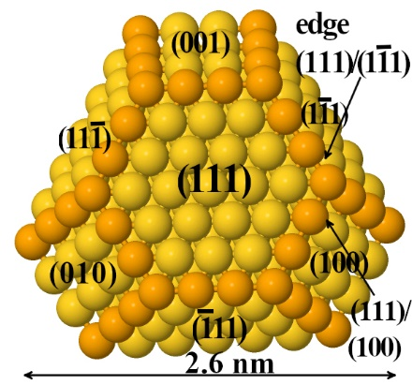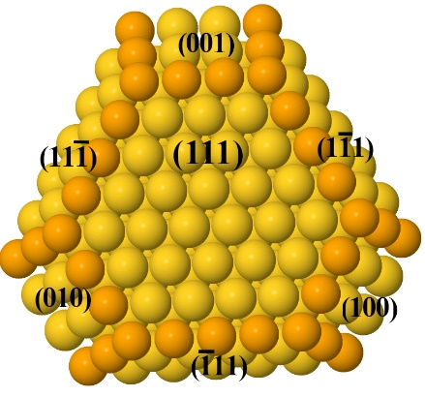

**(111)/(111) (B3,3)**

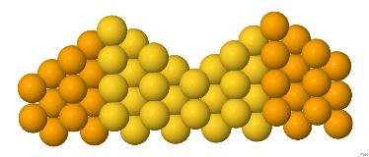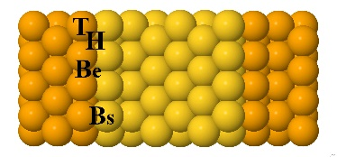

**(111)/(100)**

**(A1,3)**

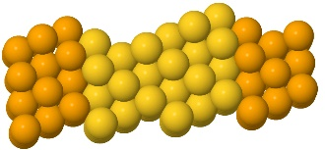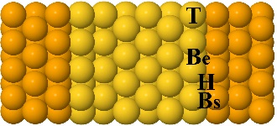

**(111)**

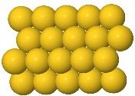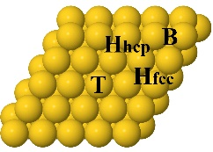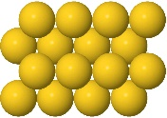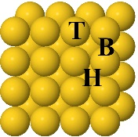

**(100)**

**Side**

**view**

**Top view**

**Figure 1** *Top views of truncated octahedrons and the side and top views surface models used to simulate the edges between the microfacets and surfaces of nanoparticle. From left to right the edge between (111)/(111) type microfacets (B3,3), the edge between (111)/(100) microfacets (A1,3) and (111) and (100) surfaces*

We have studied the dissociation of C-Cl/C-Br/C-I bonds in chloro/bromo/iodo-benzene molecules on the above proposed surfaces that build the nanoplatelet nanocluster, as the elementary step in the mechanism of C-C cross-coupling reaction. Top view of the initial, transition and final state structures for ClC6H5 dissociation are shown in Figure 2 together with the reaction energies.

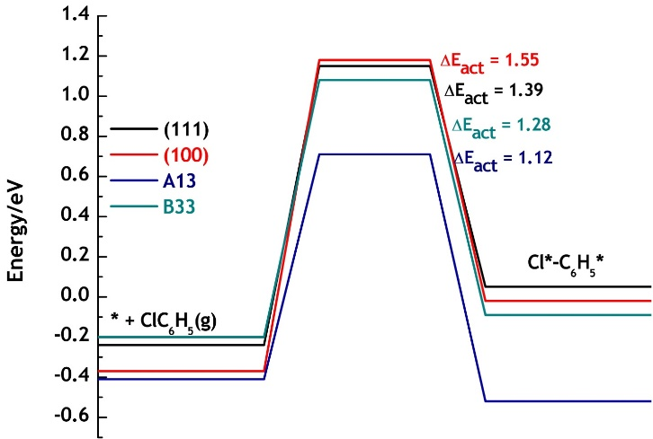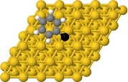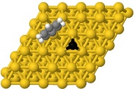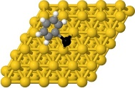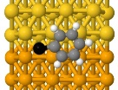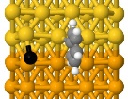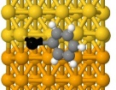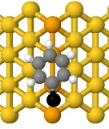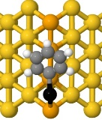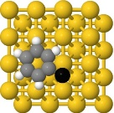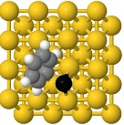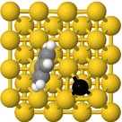

**(111)**

**(100)**

**B33**

**A13**

**∆Eads,ClC6H5\***

**∆Eads, Cl*,C6H5\***

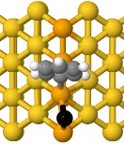

***Figure 2*** *Energy profiles for Cl-C dissociation on Au(111), Au(100), Au(B33) and Au(A13) surfaces.*  *Legend yellow and orange balls- gold atoms, gray - carbon, white – hydrogen, black - chlorine atoms****.***

Different orientations of the molecules relatively to each surface were tested (not shown). On the flat surface Au(111) the three molecules bind parallel to the surface, quite weakly and only small differences among their adsorption energies are registered with iodobenzen adsorbing slightly stronger than the other two (∆Eads = -0.26 eV for cholorbenzen, ∆Eads = -0.33 eV for bromobenzen and ∆Eads = -0.42 eV for iodobenzene). On the other three surfaces the molecules adsorb as well parallel to the edges. The binding energies on A13 are approximately the same as on flat surface, while on B33 are slightly weaker (≈0.20 eV) due to lower contact surface with the edge. Dissociation of C-Cl on (111) flat surface requires quite high energy of 1.47 eV, while C-Br and C-I require less energy, 1.04 eV and 0.77 eV respectively. On A13 and B33 surfaces the energy for dissociation decrease slightly for each bond type. This decrease is not significant though (1.29 eV for C-Cl, 0.85 eV for C-Br and 0.58 for C-I). As one can notice the most difficult bond to break is C-Cl, followed by C-Br and by C-I. The exothermicity of the reactions increases in the same order. As a short conclusion, the two step edges (A13) and (B33) are slightly more active than the flat surfaceS (111) and (100) in terms of C-X dissociation. From this theoretical perspective is expected that up to a certain extent the reaction with iodobenzene to give higher yields, and the reaction with chlorobenzene to require higher temperatures and longer times from this point of view. But the complete reaction means C-C coupling and also release of Cl/Br/I compounds from the surface. Some of the these aspects are going to be investigated in the next steps of the project such as to establish if for example is any poisoning effect that can decrease the yield of the reaction. As described above the reaction with ClC6H5 gives higher yields than the reaction with IC6H5. Therefore the aspects related to poisoning has to be cleared out as well from computational point of view.

**2.1.2 Gold clusters**

Because there is the possibility to have on the graphene sheets deposited small clusters that coexists with the larger nanoparticles we have investigated the interaction of bromobenzene on the gold clusters of 3, 4, 5, 6 atoms when placed in vacuum or when placed on undefected graphene sheet of zigzag shape (Gz) (Figure 3). The studies indicate that gold clusters up to 9-10 atoms are in 2D shape [5]. Moreover the number of possible conformations for each cluster increases with the number of atoms. Therefore in our calculations we deal only with planar clusters and we have chosen the most stable clusters that are predicted by theoretical investigations [6]**:**

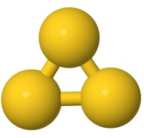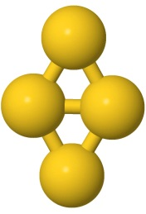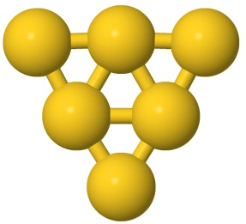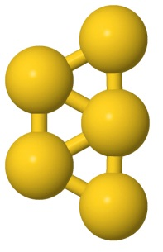

**Au3**

**Au4**

**Au5**

**Au6**

***Figure 3*** *Gold clusters with 3, 4, 5, 6 atoms*

As can be seen the clusters are stabilized by adsorbance on Gz (ΔEads < 0). When deposited on undefected Gz sheet, the three atom Au3 cluster is the most stable when adsorbed perpendicular to the surface with one gold atom connecting with the surface through C atom (see in Table 1 top and side view of investigated structure, ΔEads-Au3 = -0.56 eV). The next adsorption configuration that is stable, is when is adsorbed parallel to the surface (ΔEads-Au3 = -0.42 eV). As the number of gold atoms in the cluster increases, the parallel orientation of the gold planar cluster to the Gz surface become the most stable conformation and the adsorption energy increases due to the vdW forces (see Table 1 for 4, 5 and 6 atoms).

**Table** 1 *Optimized geometries of gold clusters (Au3-6 atom clusters) adsorbed on perfect graphene (armchair surface) and their adsorption energies. Legend: yellow-gold atoms/gray carbon atoms*

|  |  |  |  |
| --- | --- | --- | --- |
|  | **Top view** | **Side view** | **ΔEads/eV** |
| **Au3** |  |  | -0.56 |
|  |  | -0.42 |
| **Au4** |  |  | -0.63 |
|  |  | -0.49 |
|  |  | -0.11 |
| **Au5** |  |  | -0.62 |
| **Au6** |  |  | -0.67 |

Further on, we choose BrC6H5 molecule to investigate its adsorption and Br-C dissociation energy on the unsupported and Gz supported clusters.

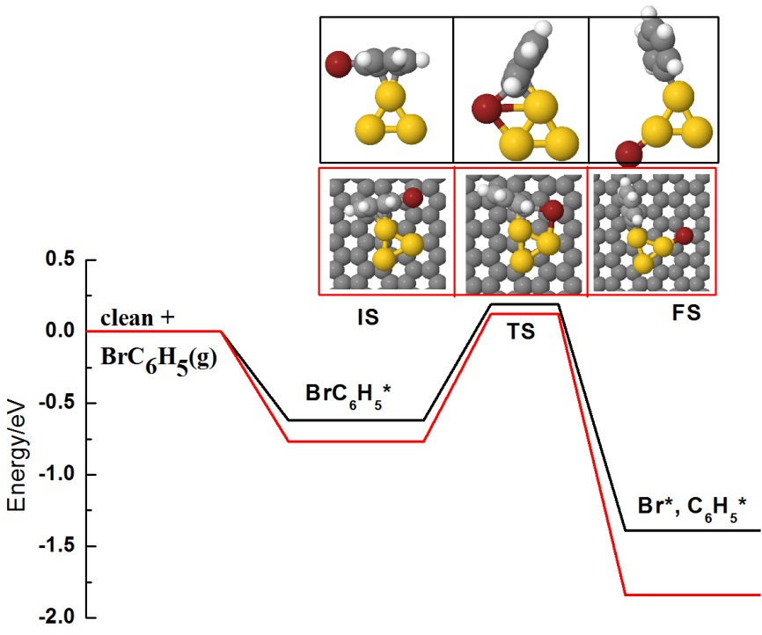

**∆Eads,BrC6H5**

**∆Eads,Br*,C6H5\***

***Figure 4*** *Energy profiles for Br-C dissociation on Au3 and Gz-Au3 systems*

In the following we depict the results for Au3 and Au5 clusters.

On unsupported Au3 cluster the most stable adsorption structure of BrC6H5 is when adsorbs with one of the aryl C=C bonds ontop of the Au atom (see initial structure in Figure 4). Other adsorbing positions were investigated (eg. with bromine atom ontop Au atom) are slightly less stable than the most stable one (not shown).

For the system with the cluster adsorbed on the graphene sheet, the most stable adsorption conformation is the one with the cluster adsorbing parallel to the surface and with the aryl cycle of the brombenzene molecule pointing to it through the C=C (see the initial structure in Figure 4, ΔEads = -0.77 eV). We have tested as well the structure with BrC6H5 adsorbing direct on the Gz sheet next to the gold cluster and it binds weaker than when interacts with the cluster (ΔEads = -0.45 eV). Therefore this is an indication that Au3 cluster can induce the adsorption even if deposited on the undefected graphene. Concerning the activation energy of Br-C bond dissociation, it doesn’t vary almost at all when passing from the unsupported cluster to Gz supported (ΔEr = 0.82 eV vs. 0.89 eV). This activation energy is comparable also with the one obtained for Au(A13) and Au(B33) surfaces. Therefore even though the dimensions of the cluster is the smallest possible with the gold atom where the dissociation takes place being strongly uncoordinated (2c) compared to the atom from Au(A13) (7c), do not manage to activate better the Br-C bond. At this point the support does not affect this activation, either. The explanation might be mostly based on the fact that on Au(A13) the vdW forces are the one that prevail over the undercoordination number (in small clusters where the coordination is the one that is responsible for the reactivity while on higher coordination surfaces the vdW forces are the one responsible with the surface activity)

The next planned investigations by inducing defects in the graphene sheet will reveal if the defects have the power to activate better the Br-C bond.

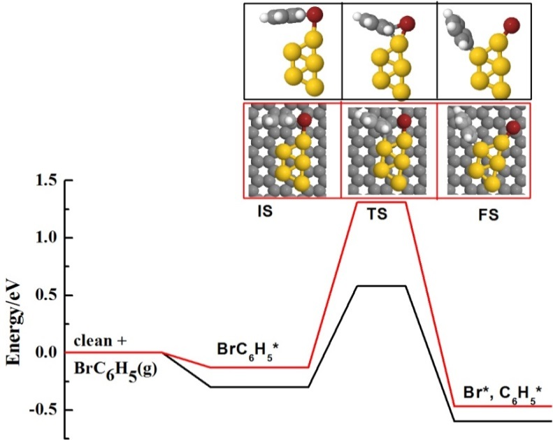

***Figure 5*** *Energy profiles for Br-C dissociation on Au5 and Graf-Au5 sistems*

On Au5, the adsorption energy of BrC6H5 lies in-between -0.22 to -0.30 (structures not shown) for different adsorption positions. For this cluster it starts to get more stable the structures in which the bromine atom of the molecule points ontop gold atom of the cluster, but the energy differences are quite small and any of them could be encountered. When binds on the Au5-Gz system, the adsorption energy is only slightly weaker than on the cluster in vacuum. The activation energy for Br-C dissociation is pictured in Figure 5. On unsupported cluster the activation energy is approximately 0.8 eV, therefore is a value quite close to the values obtained for edges of larger nanoparticles (see above). When is supported on the graphene sheet, the activation energy increases to approximatively 1.3 eV. We suppose that this significant increase of energy might be due to the fact that during the dissociation the cluster moves around and therefore helps to dissociation as well, while when is deposited on undefected graphene its movement is slightly more difficult due to the dispersion forces developed between graphene sheet and planar cluster.

In both all cases the reaction energy is exothermic (on Au3/Au3-Gz slightly more exothermic than on Au5/Au-Gz systems)

**References**

1. Candu, N.; Dhakshinamoorthy, A.; Apostol, N.; Teodorescu, C.; Corma, A.; Garcia, H.; Parvulescu, V. I., Oriented Au nanoplatelets on graphene promote Suzuki-Miyaura coupling with higher efficiency and different reactivity pattern than supported palladium. *Journal of Catalysis* **2017,***352*, 59-66.

2. Ana Primo, I. E. A., Simona N. Coman, Natalia Candu, Vasile I. Parvulescu. Hermenegildo Garcia, One‐Step Pyrolysis Preparation of 1.1.1 Oriented Gold Nanoplatelets Supported on Graphene and Six Orders of Magnitude Enhancement of the Resulting Catalytic Activity. *Angewandte Chemie International Edition* **2015,***55* (2), 607-612.

3. Mateo, D.; Esteve-Adell, I.; Albero, J.; Royo, J. F. S.; Primo, A.; Garcia, H., 111 oriented gold nanoplatelets on multilayer graphene as visible light photocatalyst for overall water splitting. *Nature Communications* **2016,***7*, 11819.

4. Enkovaara, J.; Rostgaard, C.; Mortensen, J. J.; Chen, J.; Dułak, M.; Ferrighi, L.; Gavnholt, J.; Glinsvad, C.; Haikola, V.; Hansen, H. A.; Kristoffersen, H. H.; Kuisma, M.; Larsen, A. H.; Lehtovaara, L.; Ljungberg, M.; Lopez-Acevedo, O.; Moses, P. G.; Ojanen, J.; Olsen, T.; Petzold, V.; Romero, N. A.; Stausholm-Møller, J.; Strange, M.; Tritsaris, G. A.; Vanin, M.; Walter, M.; Hammer, B.; Häkkinen, H.; Madsen, G. K. H.; Nieminen, R. M.; Nørskov, J. K.; Puska, M.; Rantala, T. T.; Schiøtz, J.; Thygesen, K. S.; Jacobsen, K. W., Electronic structure calculations with GPAW: a real-space implementation of the projector augmented-wave method. *Journal of Physics: Condensed Matter* **2010,** *22* (25), 253202.

5. Johansson, M. P.; Warnke, I.; Le, A.; Furche, F., At What Size Do Neutral Gold Clusters Turn Three-Dimensional? *The Journal of Physical Chemistry C* **2014,** *118* (50), 29370-29377

6. Baek, H.; Moon, J.; Kim, J., Benchmark Study of Density Functional Theory for Neutral Gold Clusters, Aun (n = 2–8). *The Journal of Physical Chemistry A* **2017,** *121* (12), 2410-2419.

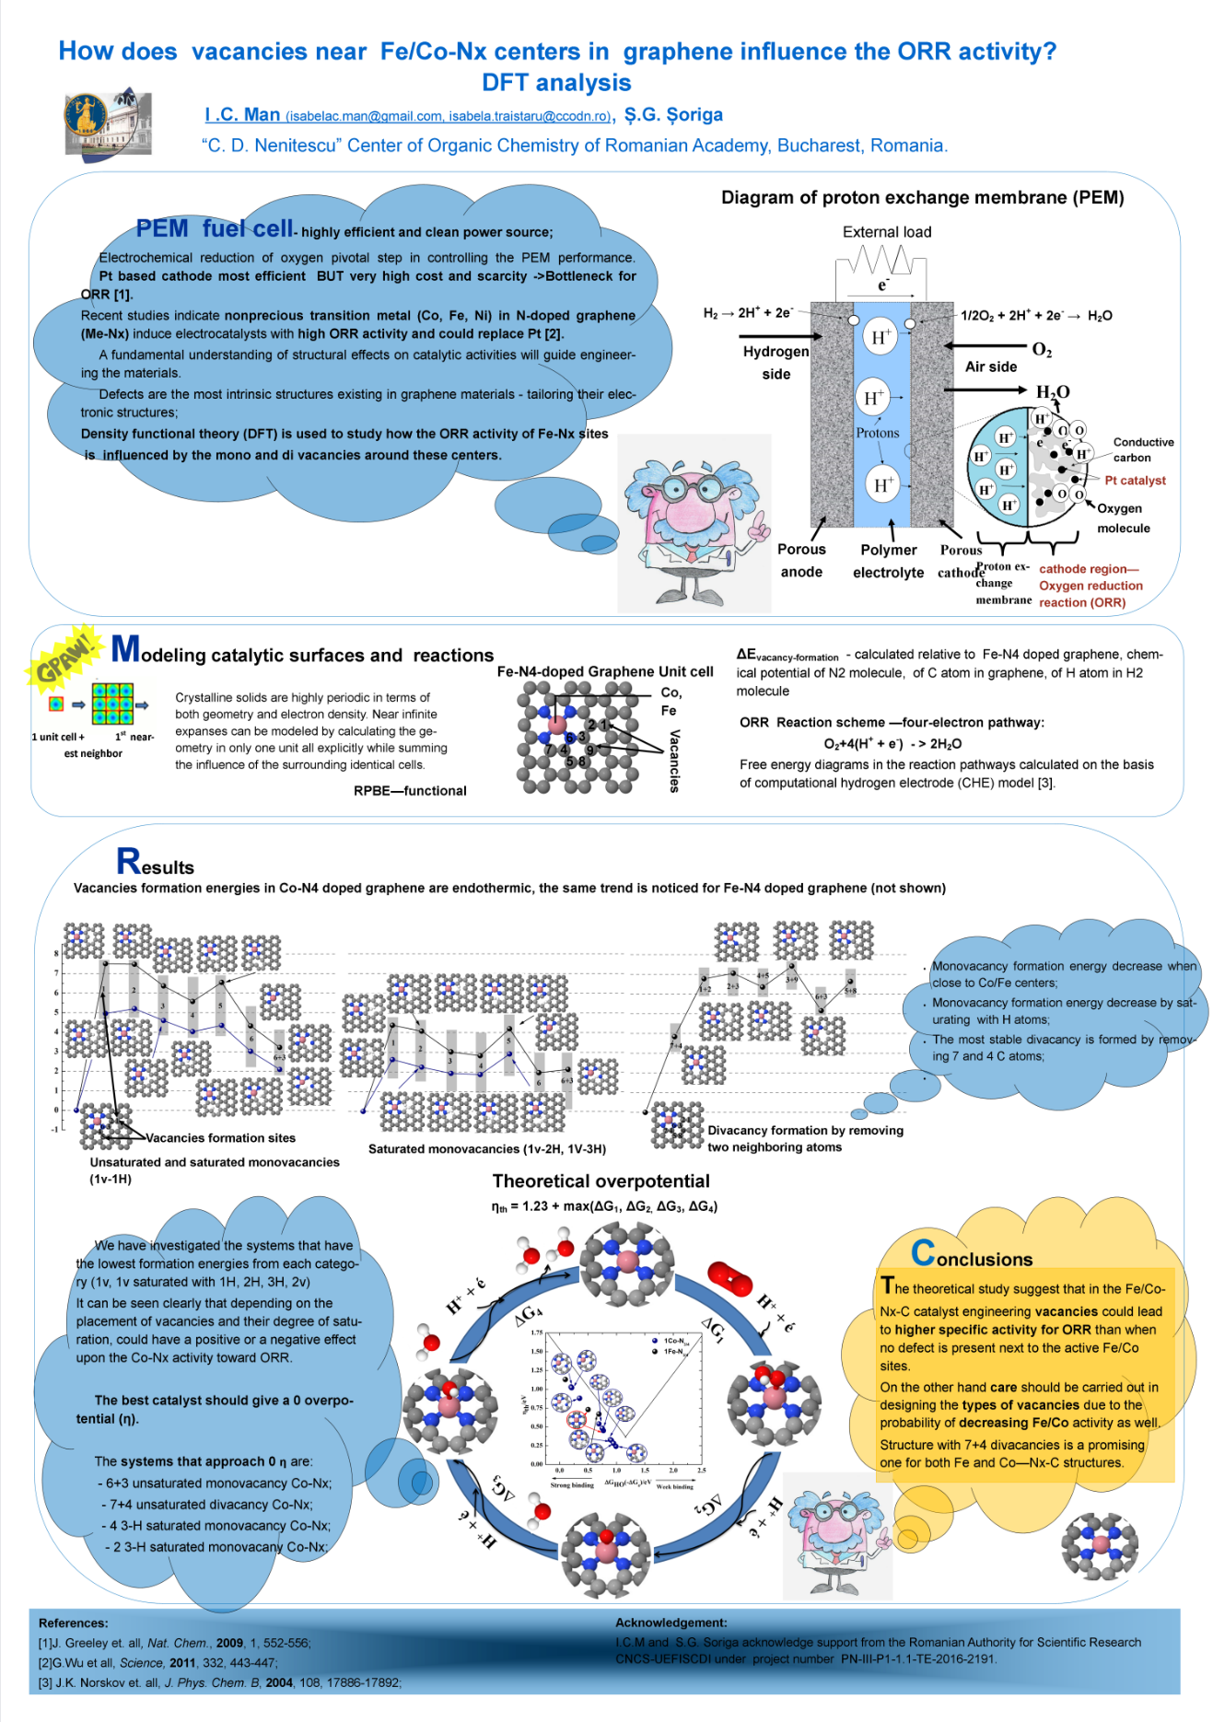 **Theoretical testing of porphyrinic FeN4 structures for ORR-see the data presented at the Northern Catalysis Symposium, August, Copenhagen, Denmark**